**King Abdul Aziz University**

**Faculty of Computing and Information Technology**

**Department of Computer Science**

Developing an Online Developer Community (Report-I)

09.25.2018

## Prepared by

Azargul (1414322)

Supervisors

Prof. Isa Fathi & Prof. Kamal Jambi

**Abstract** **2**

**Introduction** **3**

Motivation 4

**Project Proposal** **4**

Problem Definition 4

Project Scope 4

Project Type 4

Target Users 4

Suggested Solution 5

**Project Management** **5**

Work Breakdown Structure (WBC) 5

**Project Technologies** **7**

Languages 7

**Future Work** **8**

**References:** **9**

# Abstract

The aim of this project is to develop an online community application to let the software developers to chat, share their ideas through drawing or generating UML diagram from source code.

# Introduction

Though, there are many online communities which their main aim is to keep connected the developers around the world, these communities have different ways of communication such as GitHub which lets the developers to communicate through sharing codes and commenting on a specific issue of the code, Stack Overflow is another Q&A website for developers which lets the developers to answer, share and develop each others problem and there are many other websites such as StackExchange, Quora, Medium, Mozilla Developer Network and many others. What I really didn’t observe during my research about online developer communities is that there isn’t such a website which allow the software developers to communicate through exchangning generated UML diagrams of modules of code. For example, a developer wants to share his code by its generated UML diagram from its source code, so let's take an example, you have coded a new software and there are some other developers who want to see your code in UML diagram format, in this case you can communicate with other developers through a media which could generate UML diagram from your module of Java code. My project is about to create an online developer community platform for different types of programming languages and frameworks which let the developers to come and communicate with other developers of the specific community.

My project is about to develop a website which let the public users to visit different available communities and see the chat of others and if the user want to share his/her idea then he/she needs to be signed in or sign up to the system. The user can draw and store his UML diagram through drag and drop of UML components or he/she can generate UML diagram through a module of Java code, he/she only needs to upload his/her module and the system generate the UML diagram for them.

## Motivation

One of the main reason behind why I want to develop this project is because of the extreme interest which I have toward web technologies and software development related works which led me to learn more about new web technologies during development of this project and I am very passionate about my project since I started.

# Project Proposal

## Problem Definition

This project is about creating an online developer community to share their code through its generated UML diagram or to draw UML diagram and share it with other developers. The problem is about generating UML diagram by user through uploading the module of code to the server by the user. Another problem is about drawing UML diagram through drag and drop of UML components.

### **Project Scope**

The scope of the project is:

* Creating a server side program to generate UML diagram through uploaded files
* Creating a client side interface to show the generated UML diagram
* Creating a client side program to let the users to draw their UML diagram
* Creating the chatting service for the users
* Learning full stack development

### 

### **Project Type**

The type of this project is a web application that let the users to chat, share their UML diagram and to draw UML diagram.

### **Target Users**

The main users of this project will be the software developers.

## Suggested Solution

In the server side, I will create a program that will read the uploaded files from the clients and extracts the class information of each individual source files and store them on a specific object. The server sends back the extracted information of the uploaded source code to the client in JSON format. The client will read the received JSON input and Javascript will create the UML diagram through manipulating the HTML5’s SVG and Canvas objects.

To draw the UML diagram in client side, I will use the maxgraph library to let the users draw UML diagram by drag and drop option.

# Project Management

## Work Breakdown Structure (WBC)

Work Breakdown Structure is one of the best ways to break a large or difficult task into more smaller, more manageable subtasks. So, Work Breakdown Structure helps team members to know what tasks that must be done to complete the project and to understand how all of the tasks fit into the overall design project. In summary, Work Breakdown Structure defines and groups a project's discrete work elements in a way that helps organize and define the total work scope of the project[1]. WBC shown in figure 1.

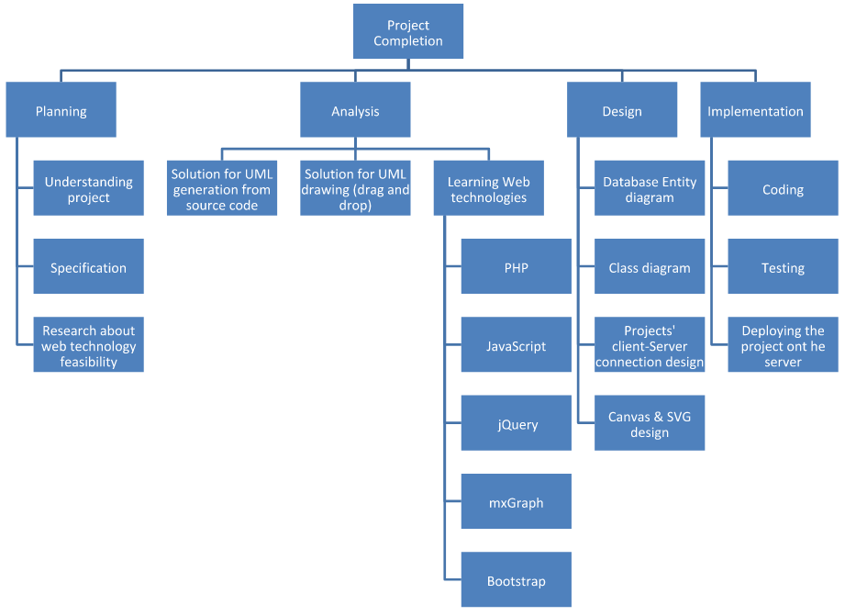

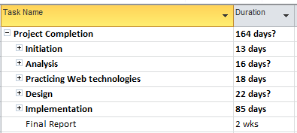

Figure 2. Shows the time estimation for complete project

Gantt Chart

In the below figure, you will see the project’s total tasks in Gantt chart format which during these two semesters it will be done.

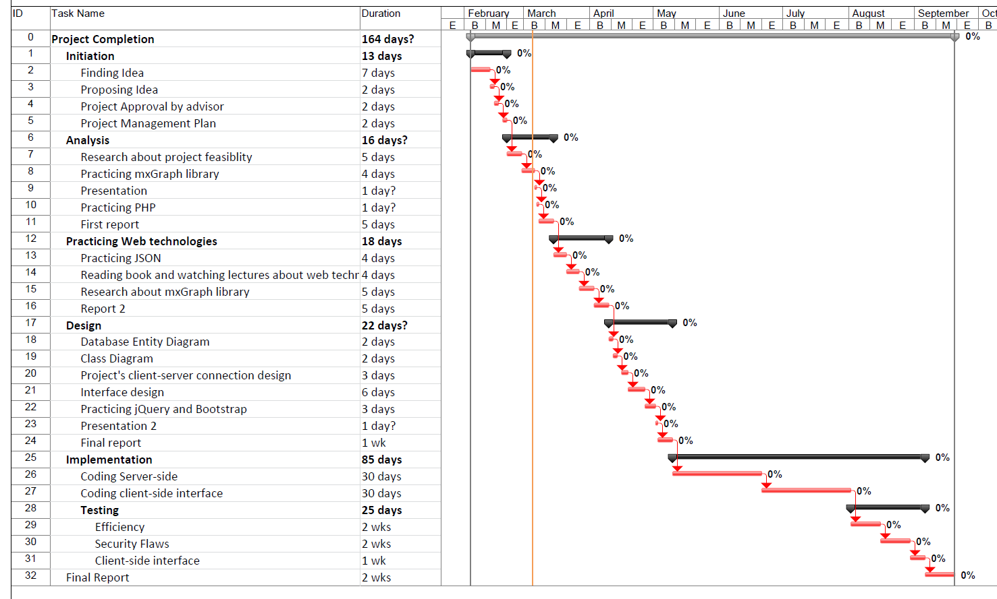

Deliverables

By the end of the project, the outcomes or overall results :

* completely finish the project.
* test out results of the project.
* prepare and present final oral presentation that describe what we have done in the whole project.
* final documentation of the project.

# Project Technologies

## Languages

* **PHP**: PHP originally stood for Personal Home Page, but it now stands for the recursive acronym PHP: Hypertext Preprocessor. PHP code may be embedded into HTML code, or it can be used in combination with various web template systems, web content management systems, and web frameworks[1].
* **JavaScript** : JavaScript is a cross-platform, object-oriented scripting language. It is a small and lightweight language. Client-side JavaScript extends the core language by supplying objects to control a browser and its Document Object Model (DOM)[2].
* **MySQL** : MySQL is a freely available open source Relational Database Management System (RDBMS) that uses Structured Query Language (SQL). SQL is the most popular language for adding, accessing and managing content in a database. It is most noted for its quick processing, proven reliability, ease and flexibility of use[3].
* **HTML** : HTML (Hypertext Markup Language) is the set of markup symbols or codes inserted in a file intended for display on a World Wide Web browser page. The markup tells the Web browser how to display a Web page's words and images for the user[4].
* **CSS**: CSS stands for Cascading Style Sheets. CSS describes how HTML elements are to be displayed on screen, paper, or in other media. CSS saves a lot of work. It can control the layout of multiple web pages all at once[5].

FrameWorks:

* **mxGraph** : mxGraph is a fully client side JavaScript diagramming library that uses SVG and HTML for rendering.draw.io is an example that extends the functionality of this library[6].
* **jQuery** : jQuery is a fast, small, and feature-rich JavaScript library. It makes things like HTML document traversal and manipulation, event handling, animation, and Ajax much simpler with an easy-to-use API that works across a multitude of browsers[7].
* **W3.CSS**: W3.CSS is a modern CSS framework with built-in responsiveness: Smaller and faster than any other CSS frameworks[8].
* **Other jQuery Plugins**

# Future Work

In future I will start working on its design phase and creating the interface prototyping.

# References:

1. <https://en.wikipedia.org/wiki/PHP>
2. <https://developer.mozilla.org/en-US/docs/Web/JavaScript/Guide/Introduction>
3. <https://www.siteground.com/tutorials/php-mysql/mysql/>
4. <https://searchmicroservices.techtarget.com/definition/HTML-Hypertext-Markup-Language>
5. <https://www.w3schools.com/css/css_intro.asp>
6. <https://github.com/jgraph/mxgraph>
7. <https://jquery.com>
8. <https://www.w3schools.com/w3css>